Fail2ban modification in the installation processus on CentOS
On ubuntu nothing needed to be modify since it was the latest version of the server.
Command use : sudo dnf install fail2ban
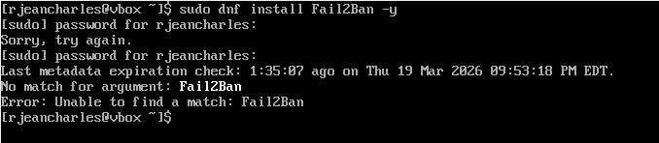
Command use : sudo dnf install fail2ban -y
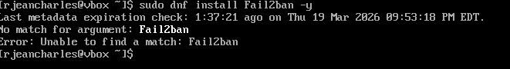
Fail2Ban cannot be installed using default repositories because it is not available in BaseOS or AppStream.”
Installing repository epel
Command use :sudo dnf install epel-release -y
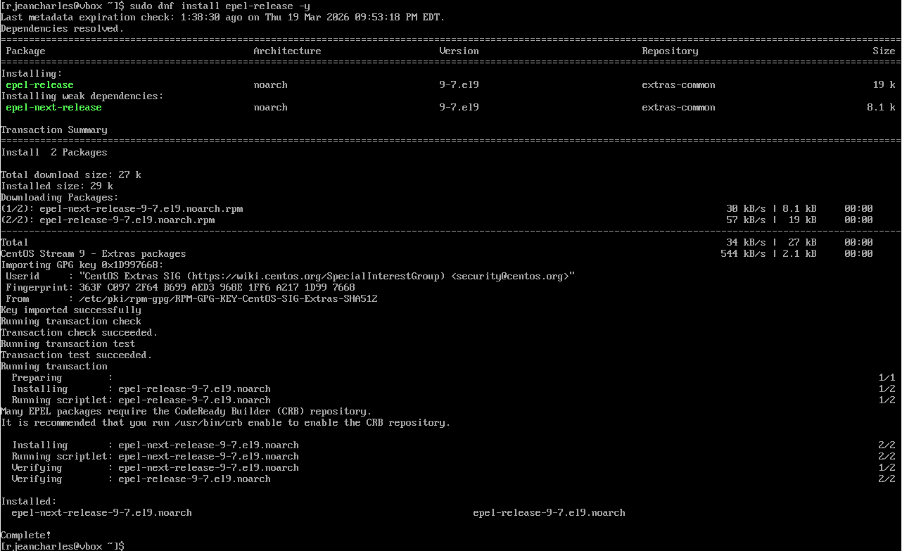
Verify repositories list
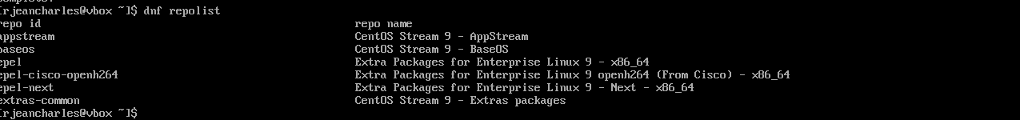

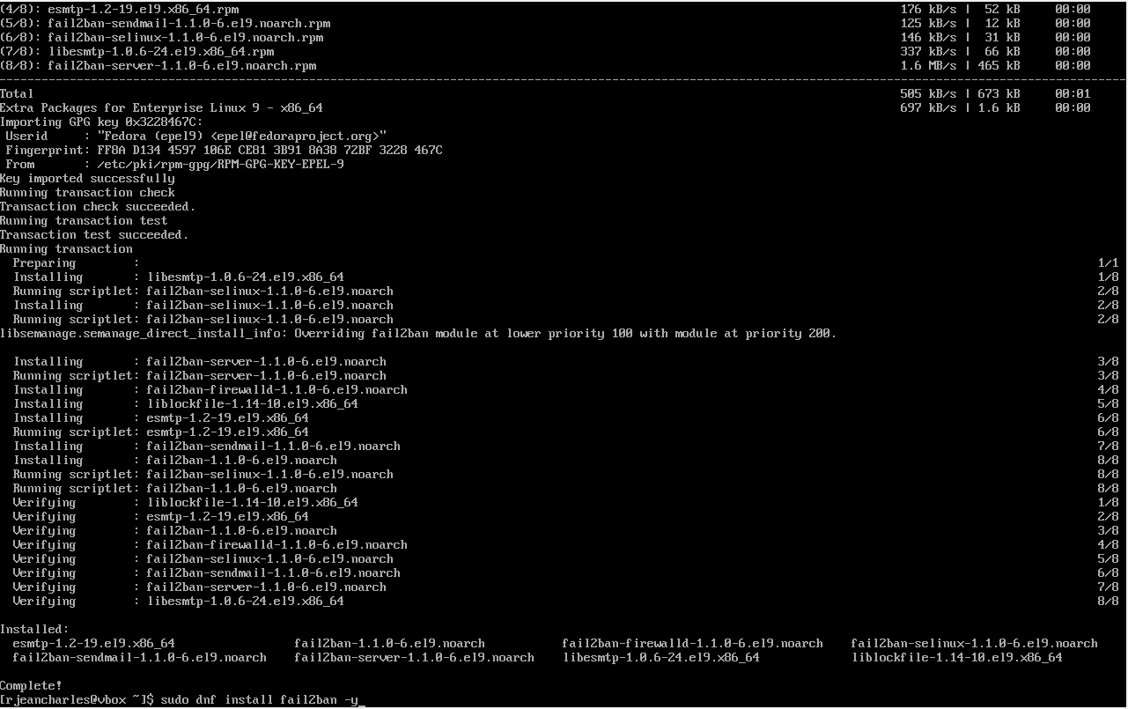

Verify the status of fail2ban after being installed
Command use : sudo systemctl status fail2ban
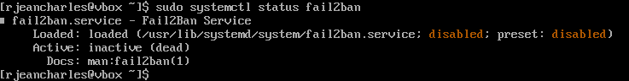

Type in to configurated fail2ban
Command use to open it : sudo nano /etc/fail2ban/jail.local
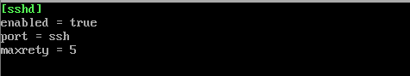

Restart fail2ban to make sure it’s working
Command use : sudo systemctl restart fai2ban

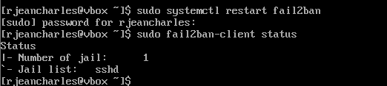

Modification made for emacs on ubuntu

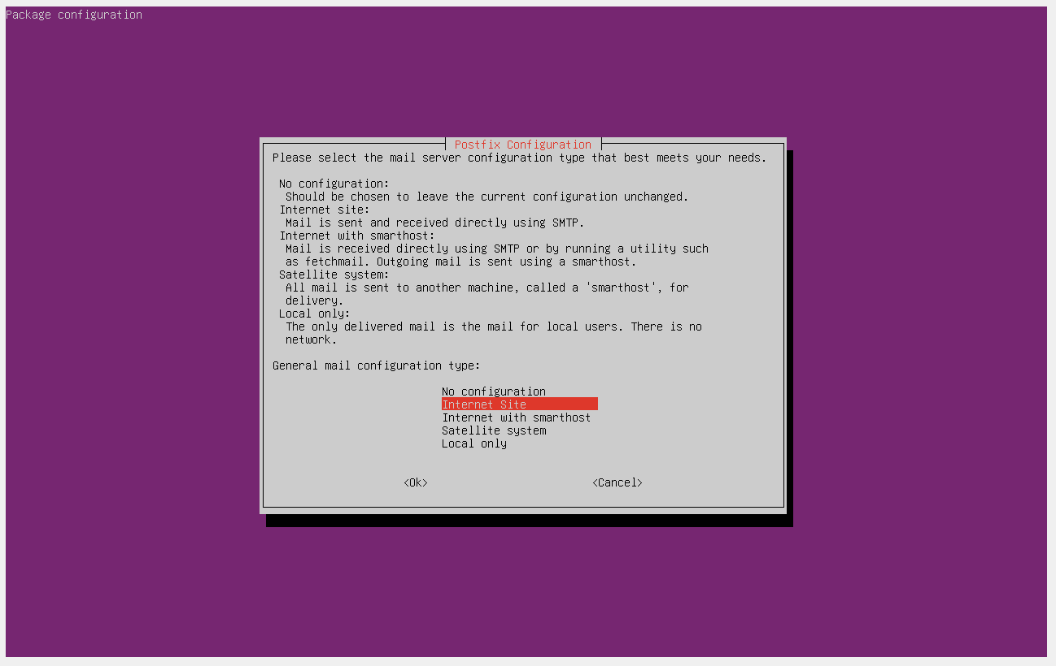
While installing, Postfix configuration appears. It is important to select local only because the system will not be use as a mail server
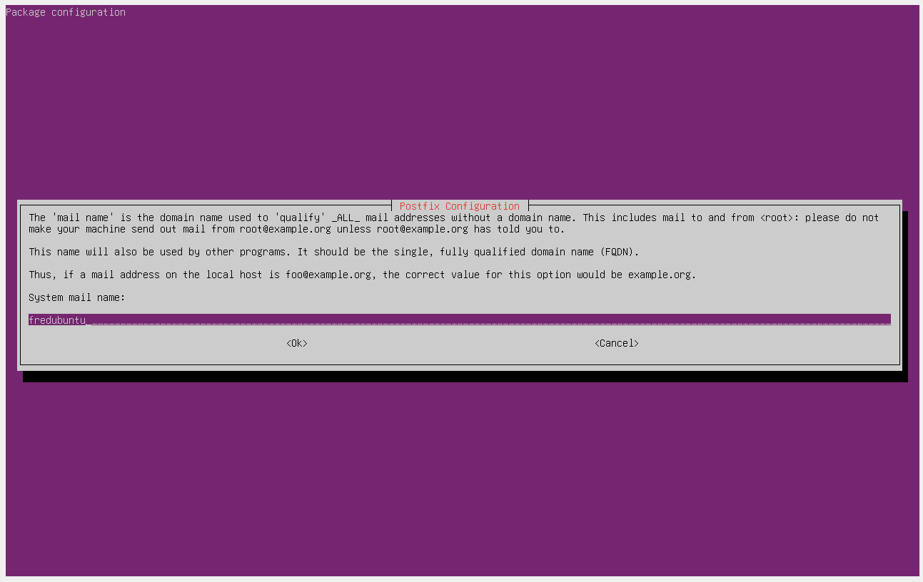
Here press Tab and click enter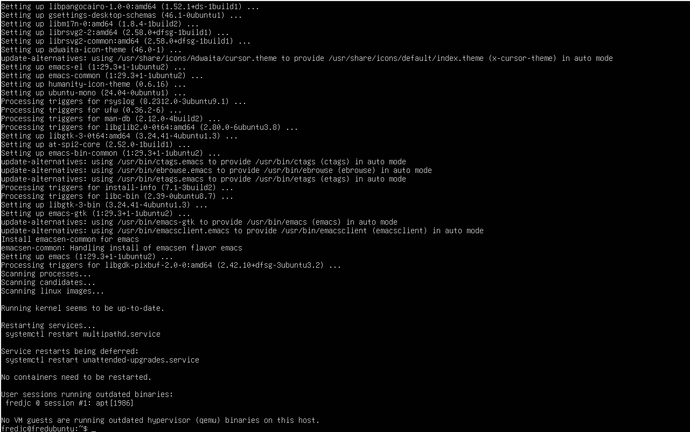
The Installation is complete for emacs after configuring postfix, selected Local Only to not set up a mail server.

Installing Fail2ban on Ubuntu
Command use : sudo apt install fail2ban -y

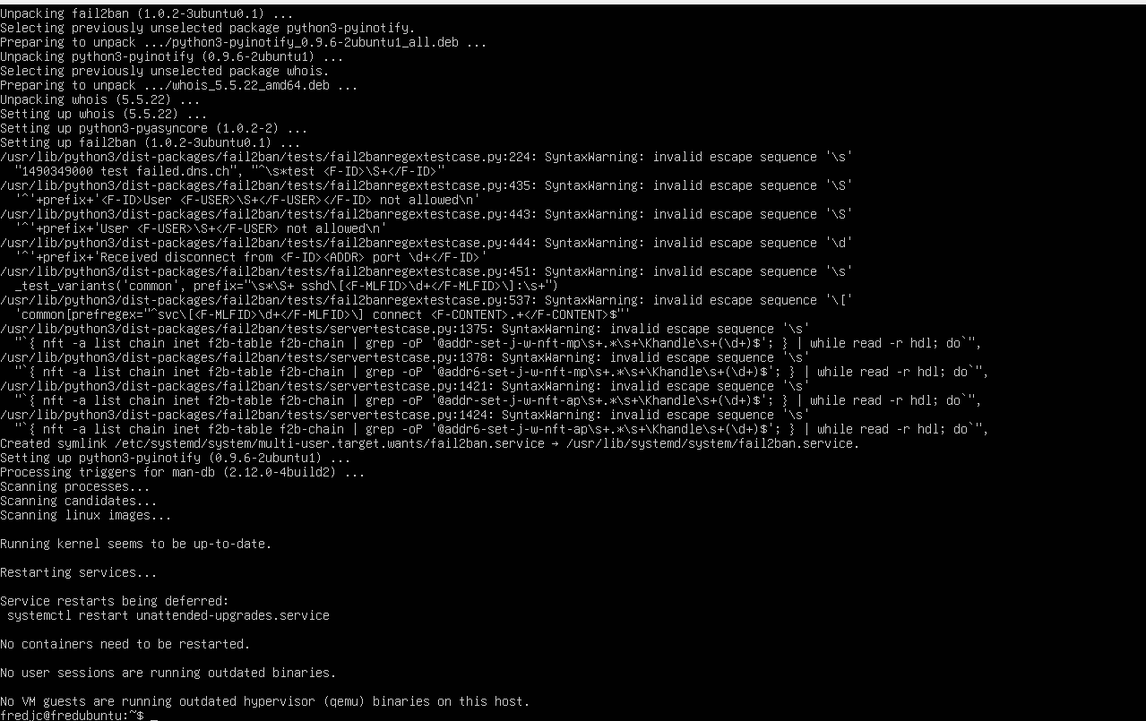
Fail2ban is completely installed
It is intalled without needing an additional repository unlike CentOS where EPEL were required.

Configuration on ubuntu
Command use : sudo nano /etc/fail2ban/jail.local
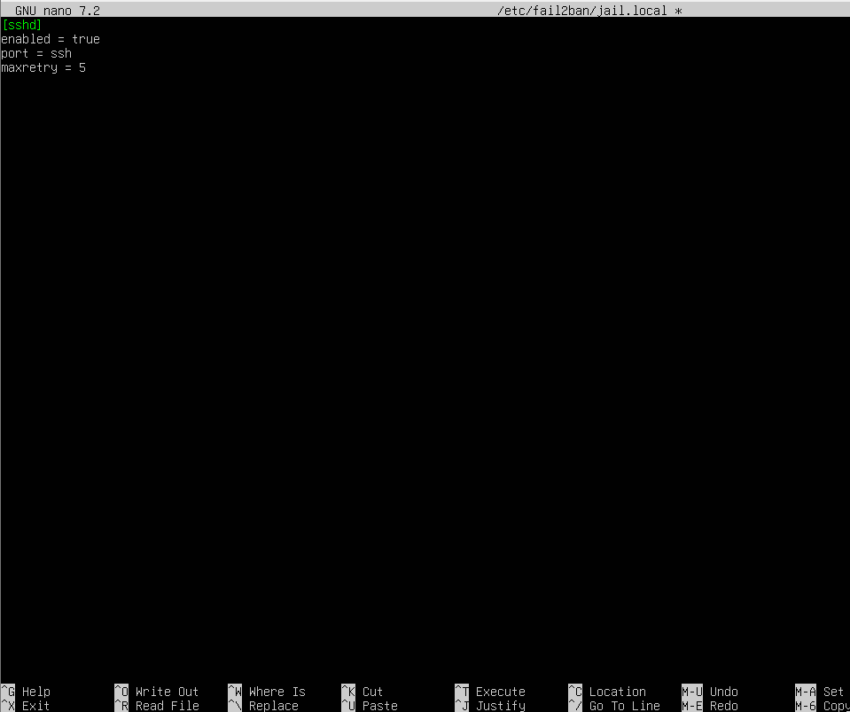
Save file

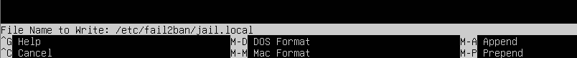

Command use : sudo systemctl enable fail2ban
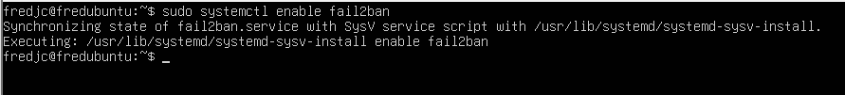
Command use : sudo systemctl enable fail2ban
sudo systemctl start fail2ban
sudo fail2ban-client status
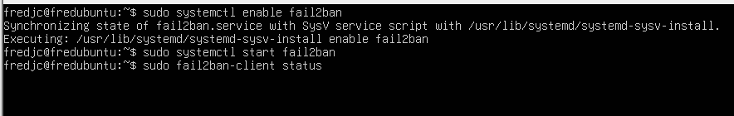
Run and verify If fail2bam is working
Command use : sudo systemctl enable fail2ban
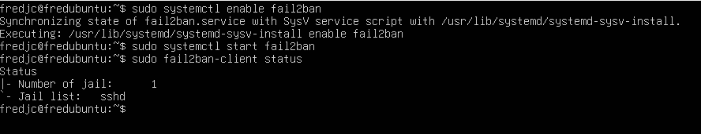
It actually working

